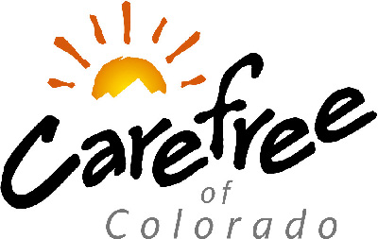

To: All Carefree Dealer Partners

Re: All Acrylic Fabric Colors

*** Acrylic Offering Changes ***

As we move forward in 2009, we are pleased to announce we are expanding our offering of standard acrylic solid colors from five to six. Furthermore, four of the existing standard acrylic solid colors will be replaced by more popular colors. This change has impacted all complete product and canopy replacement order forms. Please visit our www.e-carefree.com dealer web site for up to date order forms. The following boxes outline the appropriate changes to our standard acrylic solid color offering.

Previous Offering |  |  | New Offering Effective February 1, 2009
Color | Code |  | Color | Code
Captain Navy | 38 |  | Captain Navy | 38
Sapphire Blue | 40 |  | Linen Tweed | EA
Solid Burgundy*  *aka Black Cherry | 36 |  | Wine | UQ
Solid Teal*  *aka Persian Green | CC |  | Green | UY
Toast | CW |  | Beige | TU
 |  |  | Cadet Grey | 10

Other important changes regarding the over 140 Custom Acrylic Fabrics Carefree offers:
- Many color names and codes have changed.
- Many less popular colors have been replaced with newer, more popular colors.
- View our online swatch books at www.carefreeofcolorado.com and www.e-carefree.com for up to date, complete fabric offering.

We appreciate your business and continued support of Carefree of Colorado. If you have any further questions regarding Carefree product, please contact your Carefree of Colorado Representative.

Best Regards,

Carefree of Colorado Sales and Marketing Team

